Teacher growth and supervision observation/feedback.
Teacher Name: Jen Brown Date: November 28, 2013

What I saw :
-kids on carpet/Taking turns drawing on smart board
-counting and using movement as they counted
-stretch-movement break
-hands up to answer
-taking turns
-good progression from smart board to table
-reviewed parts of book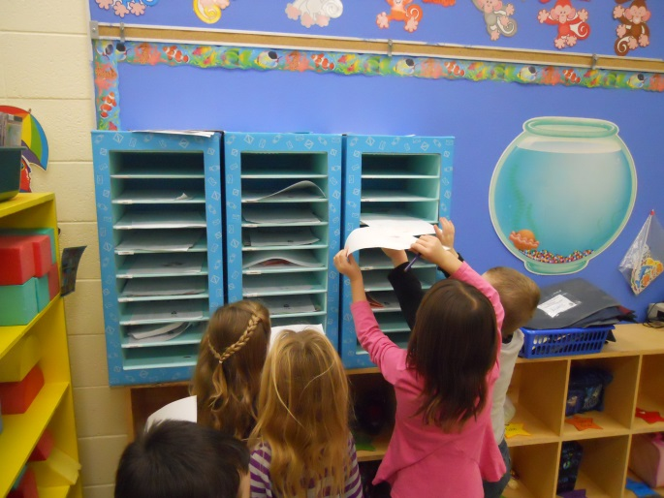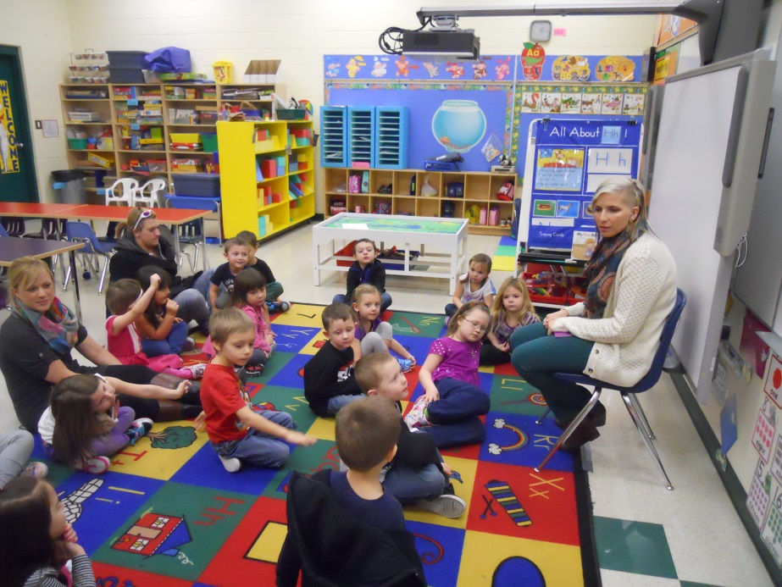
-review of colours
What I heard:
-Teacher encouraging and enthusiastic
-Let’s try…
-How else can you show 2?
-Your turn.
-Good try
-Let’s think about this..
-we have 3 different ways…
-She drew 2 shapes, what can you do?
-You are going to practice
-Miss Brown will be looking for…
-You’re a rock star!
-Put your name on
-What is this colour/shape?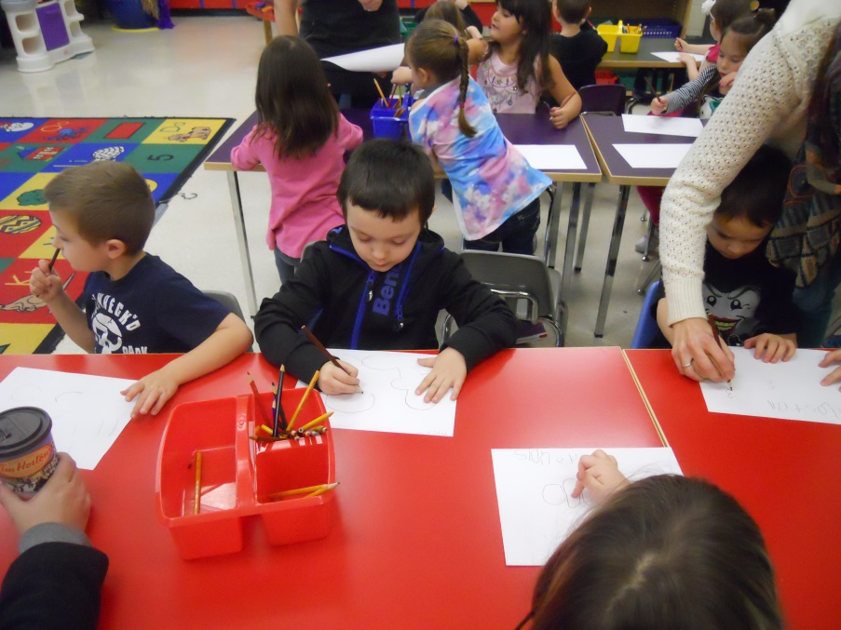
-Show me the front/back of the book
-What does the author do?
-What does the illustrator do?
-Good job!

Questions/recommendations:
Jen, You have created a very positive learning environment and you show so much encouragement and enthusiasm to your students. You were well planned and I know from our discussions that you are always looking for the best activities to reach your outcomes. I love being in your class as I’m sure each of your little ones would say. You too are a rock star!
Val B
___ KSA #1: Teachers’ application of pedagogical knowledge, skills and attributes is based on their continual analysis of the following contextual variables.
____ KSA #2: Teachers understand the legislated, moral and ethical frameworks within which they work.
____ KSA #3: Teachers understand the subject disciplines they teach.
___ _KSA #4: Teachers know there are many approaches to teaching and learning.
__x__KSA #5: Teachers engage in a range of planning activities.
__x__KSA # 6: Teachers create and maintain environments that are conducive to student learning.
____ KSA #7: Teachers translate curriculum content and objectives into meaningful learning activities.
____ KSA #8: Teachers apply a variety of technologies to meet students’ learning needs.
___ _KSA #9: Teachers gather and use information about students’ learning needs and progress.

____ KSA #10: Teachers establish and maintain partnerships among school, home and community and within their own schools.
____ KSA #11: Teachers are career-long learners

September reflection and October discussion KSA #3
October reflection and November discussion KSA #4
November reflection and December discussion KSA #5
December reflection and January discussion KSA #6
January reflection and February discussion KSA #7
February reflection and March discussion 21st Century Literacy Framework
March reflection and April discussion KSA #8
April reflection and May discussion KSA #9
May reflection and June discussion KSA #10 / KSA#11

